A Guide For
Your Wedding
From This
Day Forward…

Advent Lutheran Church
3660 Kenny Road
Columbus, OH 43220
614.451.3639 Fax – 614.451.0322
www.adventelc.org
Christian marriage is a joyous occasion.
It is first and foremost a Service of Worship

We trust that the following guidelines
will help you plan for your wedding at Advent

Table of Contents

Wedding Policies in Brief Page 3
What is a Wedding? Page 3
What is Worship? Page 4
The Sequence of the Service Page 6
The Details Page 7, 8, 9, 10, 11
Appendix
A. Suggested Readings Page 13
B. Suggested Music Page 14
C. Suggested Intent, Vows and Rings Page 15, 16, 17
D. Fees Page 17, 18
Floorplan of Facility/Contacts Page 19

This booklet is designed to help you make your wedding a truly Christian worship service and yet to make it truly your own wedding.

This booklet is yours to keep, mark it, and make notes, whatever. It’s our way to help you plan your special day.

Wedding Policies in Brief

- Those persons to be married are expected to be active participants in a Christian congregation. When both individuals are not members of Advent Evangelical Lutheran Church, approval must be obtained from the Pastor. Weddings must be on the Advent calendar at least eight (8) weeks prior to the ceremony.

- All couples will be encouraged to attend services at Advent before their wedding. The couple shall attend a minimum of three counseling sessions prior to the marriage.

- All details of the marriage service shall be at the discretion of the Pastor in consultation with the couple. Selection of music shall be made in consultation with the Pastor or the Director of Music Ministry. Non-member assisting clergy and/or visiting clergy are welcome with the prior consent of the Pastor and Church Council.

- The couple assumes the cost of materials for the service, as designated by Pastor and the Schedule of Fees or as determined by the Church Council.

- It is common courtesy to extend an invitation to the Pastor and spouse, especially if you are expecting him to be present at the rehearsal dinner and the reception.

WHAT IS A WEDDING?

Weddings are important. We want your wedding to be one of the best moments of your life that propel you to a life-long marriage.

Worship is important, too. We feel that to begin your marriage by worshipping together at your wedding is a very solid way to begin life together.

What is a wedding? It may seem like a silly question, but what is reasoning behind it? Why do we do it? A wedding is the coming together of two lives to be joined, married. That's what a wedding is, but is that the same as marriage? Not by a long shot! Marriage is "a gift of God which can only become real in the lives of two people," as one phrase has it. The wedding is "only" the outward sign of an inward union of hearts, bound together by God.

We require that each couple take an online couple inventory and meet with Pastor Aaron at least twice (about one hour each time) for premarital sessions. In those sessions Pastor Aaron will discuss with you the results of your online inventory and give you applause on what you are doing well and sound advice on items that need some growth. He will also help you plan your wedding ceremony to help make your day one to truly remember.

We do ask couples to worship with us here on Sunday mornings.

If you are interested in having your wedding here at Advent, please contact our church office at 614-451-3639.

WHAT IS WORSHIP?

We’re glad you asked that!

A wedding can mean so much more when it is worshipful. It means more to you on your special day and more to the people who are there to celebrate with you. Good worship can only enhance and beautify your wedding. It can never distract from the joy of that day. It can give meaning to your wedding because worship brings the special love God has for you to the attention of everyone that celebrates and worships with you.

There are good ways and bad ways to worship, just as there are neat and sloppy weddings. We’d like to outline certain principles of worship – things to think about as you plan your wedding service.

- Worship is an Encounter with God, our reaction to God’s action, our coming to God because God came to us in Christ. Our prayers, songs and thoughts go to God as God comes to us in word, song, blessing in the “mystical presence” we feel in Church. God and we draw close to one another. God is present – and we recognize that.
- All Worship is Christ Centered. If it weren’t for Christ we’d be nothing. Christian couples often can see Christ’s love for them reflected in their love for each other. Our worship should point to Christ as the focal point.

- We Worship Modestly. God is present and Christ is the center. In a wedding that means, frankly, that Christ is the center of attention – not the bride or the groom or any of the other things. It is a wedding service, but all these things are to add to the worship that we are giving Christ.

- We Also Worship Reverently. God is present and Christ is the Center. We give dignified credit to the One who make all this possible. Worship – especially on a good day like a wedding – should be filled with laughter, jokes, smiles, flowers, rousing music, the personal touch, colors, brightness, and sunshine. “Reverently” means that we plan and participate in worship which in all its parts respects and honors our good God.

- Wedding Worship should be “Liturgical” – following good church order, in other words. Not rigid and dogmatic, but flexibly suggesting good arrangements of songs, words and your parts in the wedding ceremony. We have included possibilities.

- And We Worship Together. Since we are together the God of Christ, the family of God, your wedding is your wedding but not just your wedding. A lot of other people will be with you too and they will either worship you or worship God with you. Design your wedding worship to help them praise God for His gifts to them and you. Point to Christ in your design of the service. Even better, include everyone in the worship by having them sing or speak or pray together.

Even as you value good worship, you have a great deal of flexibility in planning your wedding and this booklet will give you options, ideas and direction.

THE SEQUENCE OF EVENTS IN THE WEDDING SERVICE

You’ve probably been to weddings and have enjoyed them – but have never noticed their component parts until now when you have to plan your own. Now what? Here is the outline of what is:

THE TRADITIONAL ORDER OF WORSHIP

* Processional
Readings from Scripture
*
Homily/Sermon
*
Rite of Marriage
Introduction
Declaration of Intent
Vows
Exchange of Rings
Official Announcement
*
Prayers
Benediction
* Recessional

Choices: You may change the sequence of these major elements if you like. Certain optional elements are also possible. Talk it over with us before deciding.

At several places – best of all those marked with * - music can be meaningful; especially if at least one of these selections is a hymn the congregation can sing too. At most two musical selections (not counting the processional and recessional) are enough – more than that and the service begins to feel very long for those of you that will be standing.

THE DETAILS

Schedule the date and time:

It is never too early to establish the date and time of your wedding. This assures you that another wedding will not be scheduled at the same time. Advent’s Altar Guild, Wedding Coordinator and Director of Music Ministry will be notified when a wedding date is scheduled so that they can make plans for the special needs your wedding may require. See the schedule of fees for charges for the facilities and ministers.

The Church and Additional Facilities:

Advent’s Nave (worship space) seats approximately 350 persons. The aisle is 32 feet long. The Fellowship Hall can seat up to 150 people for a reception and/or a catered meal. There are 132 parking spaces in Advent’s parking lot. All parking is “on site”.

Marriage License:

Marriage licenses may be obtained at:
369 S. High Street, 8th floor, from Monday to Friday, 8:00 to 4:00 p.m. The wedding license must be given to the Pastor early in the week of your wedding along with the correctly spelled names of the two witnesses. The wedding cannot take place without a license.

The Rehearsal:

The rehearsal is traditionally held the day or evening before the wedding day. The precise time is planned for the mutual convenience of the Pastor and the wedding party members. The Pastor directs the rehearsal. When the bridal couple engages the service of an outside wedding consultant, she or he must consult with the Pastor and Advent’s Wedding Coordinator. All wedding fees must be paid and the marriage license given to Advent’s Wedding Coordinator two weeks (14 days) prior to the wedding. Your wedding cannot take place if the fees are not paid and the marriage license isn’t provided at this time.

Pre-Marital Counseling:

After the date has been scheduled, immediately schedule the first of three required pre-marriage counseling sessions approximately two months prior to the wedding. After the first session, the remaining sessions can be scheduled at the mutual convenience of the couple and the Pastor. Advent encourages all couples to use the workbook, “Prepare and Enrich” as the basis of the pre-marriage counseling. The workbook may be purchased online for $35.00.

During the second counseling session, you will meet with the Wedding Coordinator and the Director of Music to discuss the logistics of the wedding and the music to be provided.

Music:

Organist:
Advent’s organist shall play for all weddings unless other arrangements are made in consultation with the Director of Music Ministry (DMM). The organist and the Pastor are available to assist you in the selection of music appropriate for your wedding and a worship service of the church. Advent’s DMM and Pastor shall have final approval of all music selections. Advent’s organist shall be contacted as soon as possible to reserve the date/time of the wedding. The organist also attends the rehearsal. The fee for the organist is given in the schedule of fees.

Soloist:
Advent has soloist(s) available if desired. Fee(s) will be determined by the amount of music to be performed in negotiation with the soloist(s). If a non-Advent soloist(s) is to perform, it is the responsibility of that person to arrange for rehearsals with Advent’s organist.

Holy Communion:

It is permissible to celebrate Holy Communion within the context of the wedding service. Advent practices Eucharistic hospitality. Therefore, the wedding party and guests are welcome to receive the Sacrament of the Altar if they are baptized Christians believing in the real presence of Christ in the bread and wine of Holy Communion given for the forgiveness of sin.
Wedding Bulletins:

If you desire to use wedding bulletins for the convenience of your wedding guests and as a memento of your special day, it is your responsibility to obtain special bulletin covers and to make arrangements for their printing. It is also possible to have your wedding bulletins printed at Advent. The Pastor or Advent’s Wedding Coordinator can share samples with you and provide information on the marriage and worship service. The Pastor has the final review of your worship bulletin. Please present a copy to the Pastor three weeks prior to the wedding for proofing and approval. Be sure to include any parts of the service in which you would like your guests to participate.

Flowers and Decorations:

Arrangements for wedding flowers and decorations can be made with the florist of your choice and are your responsibility. You may need to arrange for your florist to view the church if they are not familiar with Advent. Arrangements to view the church should be made through the church office. You will need to consult with Advent’s Wedding Coordinator who will assist you and the florist in determining suitable decorations. The use of an aisle runner is not allowed due to safety issues related to slipping on the uneven floor surface. A unity candle may be used. If you choose not to purchase your own, one may be provided by the church.

Advents Wedding Coordinator must be notified so arrangements can be made to have the church open for the florist the day of the wedding.

Recordings:

Advent will provide a CD recording of the ceremony as a courtesy to the bride and groom if this is desired. If other recording media is desired, please make your wishes known to the Wedding Coordinator several weeks in advance so that arrangements can be made.

Photography:

Flash photography is prohibited during the ceremony, but is allowed as the bridal party enters and leaves the Nave at the beginning and end of the service. Photos may be taken of the processional and recessional from the rear of the church. A notice regarding flash photography and cell phones shall be included in the worship bulletin such as:

“In respect for this place of worship, no flash photography is allowed during the ceremony. We also invite you to turn off your cell phone to preserve the solemnity of this occasion.”

Videography:

Videography is permitted after consultation with the Pastor. Only videography that uses available light is permitted. The Pastor can direct you as to the placement of the camera(s). It is helpful to have a videographer attend the rehearsal to avoid confusion the day of the ceremony.

Dressing at the Church:

Facilities are available for your wedding party to dress at the church. You will need to advise Advent’s Wedding Coordinator when you will be arriving so the church can be opened.

No valuables may be left unattended during the wedding ceremony. While the doors to those dressing rooms will be locked, it is recommended that family and friends of the wedding party be asked to hold all valuables or that you place them in locked cars. The church is not responsible for lost or stolen valuables.

Prohibited:

Smoking, Illegal Drugs and Alcohol: Smoking and the consumption of alcoholic beverages or illegal drugs is prohibited anywhere on Advent’s property. The Ohio Revised Code prohibits the marriage of any person who has been drinking alcoholic beverages or using illegal drugs.

Throwables: Birdseed, confetti, rice, spangles, sparklers or glitter may not be used as the wedding party departs the church. The use of balloons as decorations is not allowed. Special “Wedding bubbles” are permitted. Please consult with Advent’s Wedding Coordinator as to your plans for celebration of the wedding. Please consult Advent’s “Policy for use of Facility” for our policy on other decorations and building use.

Worship Guidelines

Color of Paraments: Altar and pulpit Parament colors shall follow the liturgical church year and may not be changed to accommodate your wedding colors. The color of the Paraments for your wedding date can be determined by consulting Advent’s Wedding Coordinator or Pastor.

Lent and Holy Week: Ordinarily weddings are not scheduled during Lent (Ash Wednesday through Easter) due to the penitential tone and furnishings of the season. Wedding are never scheduled during Holy week (Palm Sunday through Easter)

Worship Space Furnishings: Chairs may be removed or added in the worship space on the condition that they be replaced by the wedding party prior to leaving the church.

The Altar and Pulpit remain in position. The Baptismal Font and Paschal Candle remain in the center aisle.

Scripture Lessons:

Determination of the Scripture lessons shall be in consultation with the Pastor. If it is your desire to have a member(s) of the wedding party read one or more scripture lessons, all readers should be at the rehearsal. Suggested appropriate scripture lessons are listed in the appendix. However, other favorite scripture readings are permissible as well as Psalms, poems, or other selections from outside the Bible. Following the principle of worship, they should extol Christ rather than the wedding couple and should illuminate Christ’s love for all people rather than for romantic love. We are open to your ideas, but again consult with the Pastor.

APPENDIX A
Suggested Readings:

The most appropriate things are those parts of scripture that mean the most to you – your favorite Psalm or verse or chapter. Think first of your own ideas.

The following are possibilities:
Genesis 1:26-31……………………………………The creation of human beings
Genesis 2:18-24…………………………………………….The creation of woman
Isaiah 63:7-9………………………………………………………..God’s goodness
Jeremiah 31:31-34……………………………………God’s new covenant with us
Psalm 1………………………………………………………………….Life with God
Psalm 23……………………………………………………...You know what that is
Psalm 45……………………………………………The king’s royal wedding song
Song of Solomon 2:10-13…………………………………………The joy of loving
Song of Solomon 8:6-7………………………………………...The power of loving
Matthew 5:1-12……………………………………………………….The beatitudes
Matthew 7:24-29…………………………………………The house built on a rock
Matthew 19:4-6……………………………Marriage as union of male and female
Matthew 22:35-40……………………………...Love, the greatest commandment
John 2:1-11…………………………………...Jesus at the wedding feast in Cana
John 15:9-16……………………………………………..Christ’s love and our love
Parts of John 17…………………………….Jesus prayer that “they may be one”
From Romans 12…………………………………..The life of the Christian couple
Ephesians 5:21-33…………………………………………...Talking to newlyweds
1 John 4:7-10……………………………………………………………..God is love
1 Corinthians 13:1-8a………………………………………Faith, Hope and Love

Praise Psalms:
Psalm 33, 100, 117, 127, 128, 136, 150
APPENDIX B
Suggested Music:
Some suggested hymns from the Lutheran Book of Worship

Title Hymn Number
Hear us Now, Our God and Father 288
Heavenly Father, Hear Our Prayer 289
Joyful, Joyful We Adore Thee 551
When All Your Mercies, O My God 264
From All That Dwell below the Skies 550
Praise to the Lord, the Almighty 543
Love Divine, All Loves Excelling 315
Oh, Blest the House 512
Sing Praise to God, the Highest Good 533 534
Oh, That I Had a Thousand Voices 542
For the Beauty of the Earth 561
Eternal God, Before Your Throne 354

Some suggested hymns from With One Voice
Jesus, Come! For We Invite You 648
A New Commandment 664
Where True Charity and Love Abide 665
Great God, Your Love Has Called Us 666
Word of God, Come Down on Earth 716
God is Here 719
Bind Us Together 748
When Love is Found 749
As Man and Woman We were Made 751
Jesu, Jesu, Fill Us with Your Love 765
Be Thou My Vision 776
APPENDIX C

Suggested intent, Vows and Rings:

You may write out your own words. That could be quite meaningful to you. So try that first, but here are some good choices if you don’t feel creative enough to write your own.

The Declaration of Intent

(Question is asked by Pastor, answered by each in turn)

- _________________ will you have _________ here present to be your wedded wife/husband? Will you love, honor and cherish __________ and keep with _____________ this bond of wedlock holy and unbroken till death you do part?

- ___________, will you take this man/woman as your wedding wife/husband, to live with ___________ according to God’s direction in the holy estate of matrimony? Will you love and comfort _______, honor and keep _______ in sickness and in health, and forsaking all others, keep only _______ as long as you live?

- Will you, ________, with the help of God take this woman/man as your wife/husband, to live together under God’s guidance and love as a Christian family? Will you love and comfort -------, honor and keep ---------- in sickness and health, in prosperity and poverty, in chaos and order, in freedom and oppression, in enthusiasm and despair. Will you leave all and love and be loyal only to __________ as long as God gives you life?

The Vows

Memorized and spoken by you or repeated phrase by phrase after the Pastor.

- I, _________, in the presence of God and these witnesses, take you, ___________________, to be my wedded wife/husband and pledge you my troth, till death us do part.

- I, ___________, in God’s presence and before family and friends, take you, _______ to be my wife/husband, to have and to hold from this day on, to love and to cherish as long as God gives us life.

- I take you, _______________, to be my wife/husband from this day forward, to join with you and share all that is to come, and with the help of God, I promise to be faithful to you as God gives us life together.

- __________, I take you to be my wife/husband from this time onward to join with you and to share all that is to come: to give and to receive, to speak and to listen, to inspire and to respond, and in all circumstances of life together, to be loyal to you with my whole life and with all my being.

- I take you, _____, to be my wife/husband. I promise before God and these witnesses to be your faithful wife/husband, to share with you in plenty and want, in joy and in sorrow, in sickness and in health, to forgive and strengthen you and to join with you so that together we may serve God and others as long as we both shall live.

- I take you, ____, to be my wife/husband from this day forward, to join with you and share all that is to come, and I promise to be faithful to you until death parts us.

- I take you, ___________, to be my wife/husband, and these things I promise you: I will be faithful to you and honest with you; I will respect, trust, help and care for you; I will share my life with you; I will try with you better to understand ourselves, the world, and God; through the best and the worst of what is to come as long as we live.

- In the name of God, I take you, _________, to be my wife/husband from this day forward. For better, for worse, for richer, for poorer; in sickness and in health, to love and to cherish until we are parted by death. This is my solemn vow.
The Exchange of Rings

Memorized or repeated phrase by phrase.

With this ring, I thee wed.

This ring is a symbol of my love and faithfulness.

_______, receive this ring as a pledge and symbol of my love and faithfulness.

_______, I give you this ring as a sign of my vow, and with all that I am, and all that I have, I honor you in the name of the Father, and of the Son, and of the Holy Spirit.

APPENDIX D

Schedule of Fees: (Also see Notes)

All fees are due to the appropriate parties two weeks
(14 days) prior to the wedding.

Members Nonmembers ^{4, 5}
Sanctuary and dressing Rooms ¹ $ 0 $ 350.00
Fellowship Hall ² $ 0 $ 350.00
Pastor $ Honorarium $ 250.00
Organist/Pianist $ 200.00 $ 200.00
Wedding Coordinator $ 150.00 $ 200.00
Janitor $ 100.00 $ 100.00
Sound System Operator $ 50.00 $ 50.00
Basic Fee Total $500.00 + $1500.00
Other Advent Musicians See Note 3 See Note 3

Notes:

- Fees for the Sanctuary and dressing rooms include the use of the Fellowship Hall and classrooms for dressing only.

- If the Fellowship Hall is used for a reception the use of the kitchen is included. If you should desire to provide a catered meal for a reception, Advent’s Wedding Coordinator should be given the contact information of the caterer. The Advent Building Use Policies are in effect.

- If other Advent musicians are to be used, fees are to be negotiated with that person (s).

- If nonmembers are being married at Advent, a deposit of $200 is required at the time you reserve the church for your wedding. All fees are payable two weeks (14 days) prior to the wedding and should be given to Advent’s Wedding Coordinator.

Checks should be made out to:

  - Building Use - Advent Evangelical Lutheran Church
  - Checks for the Pastor
  - Organist
  - Other musicians
  - Wedding Coordinator

- Members rates apply when either bride or groom is a member of Advent, or when either of the parents of the bride or groom is a member.

- A janitor’s fee is required only if a reception is held in the Fellowship Hall.
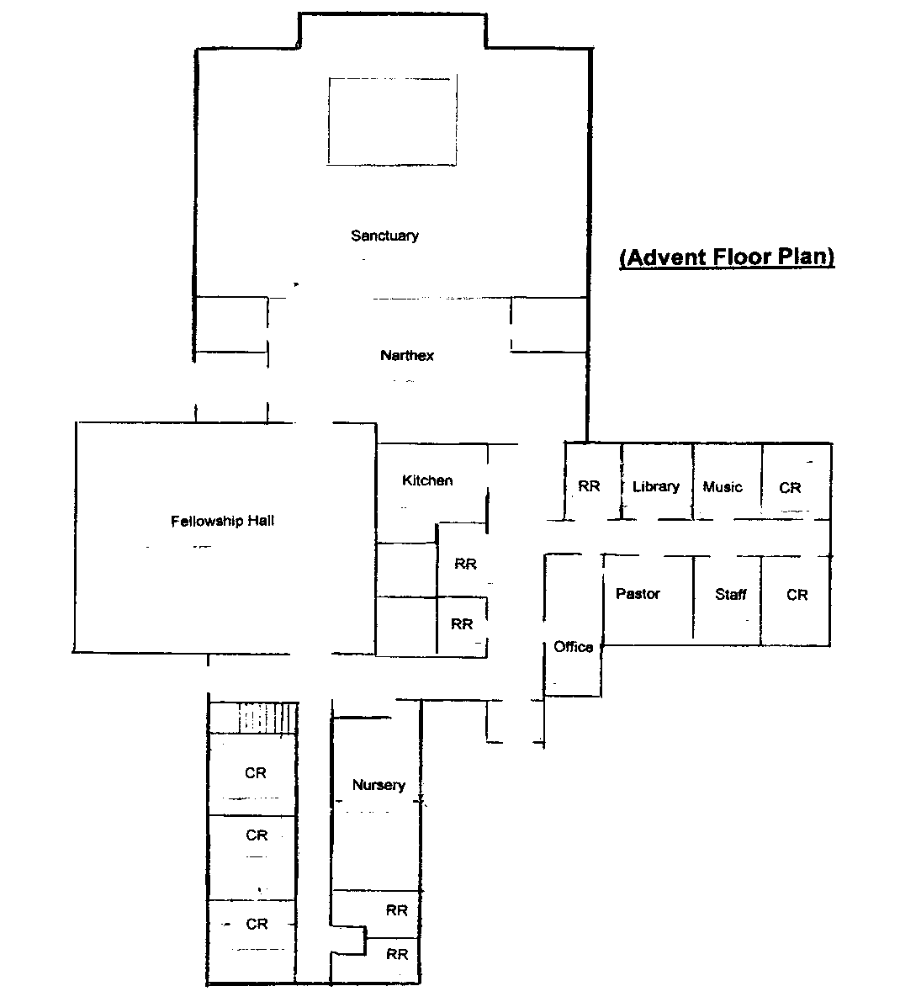
Advent Wedding Staff

Pastor: Aaron Layne 614-451-3639
Administrative Asst. Mary Garland 614-451-3639
Director of Music Ministry: Jean Pontious 614-975-6025
Organist: Jean Pontious 614-975-6025
Wedding Coordinator Julie Page 614-519-1014

