God’s Work Our Hands – Sept. 8 & 9
Items Recommended for
Blessing Bags for the Homeless
*** Travel size only please! ***

Toothbrush
Toothpaste
Deodorant
Shampoo
Razor
Shaving Cream
Comb
Chapstick
Small Bottle of Water
Lotion
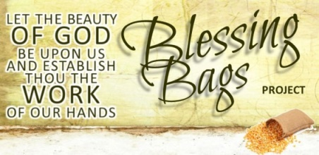
Hand Sanitizer
Gum/Mints
Band-Aids
Powder
Wet Wipes
Sanitary Napkins
Soap
Tissues
Emory Boards
Small Denomination Gift Cards
Meal Coupons

